# MODULE 5 UNIT 3

## Ongoing project: Visioning, inventing, and building credibility in your context

Learning outcome:

LO5: Recommend ways of visioning, inventing, and building credibility that will help address an organizational challenge or opportunity.

### Name: Donal Phipps

#### 1. Instructions and guidelines (Read carefully)

##### Instructions

1. Insert your name and surname in the space provided above, as well as in the **file name.** Save the file as: **First name Surname M5 U3 Ongoing Project** – **e.g., Lilly Smith M5 U3 Ongoing Project.** **NB:** *Please ensure that you use the name that appears in your participant profile on the Online Campus.*

2. Write all your answers in this document. There is an instruction that says, “Start writing here” under each question. Please type your answer there. You are also provided with a table in Question 1. Please populate this table according to the provided instructions.

3. Submit your assignment in **Microsoft Word only**. No other file types will be accepted.

4. Do **not delete the plagiarism declaration** or the **assignment instructions and guidelines**. They must remain in your assignment when you submit.

**PLEASE NOTE:** **Plagiarism cases will be investigated in line with the Terms and Conditions for Participants.**

IMPORTANT NOTICE: Please ensure that you have checked your program calendar for the due date for this assignment.

##### Guidelines

1. There are 9 pages and 3 questions in this assignment.

2. Make sure that you have carefully read and fully understood the questions before answering them. Answer the questions fully but concisely and as directly as possible. Follow all specific instructions for individual questions (e.g., “list,” or “in point form”).

3. Answer all questions in your own words. Do not copy any text from the notes, readings, or other sources. **The assignment must be your own work only.**

|  |
| --- |
| **Plagiarism declaration:** |
| **1. I know that plagiarism is wrong. Plagiarism is to use another’s work and pretend that it is one’s own.**  **2. This assignment is my own work.**  **3. I have not allowed, and will not allow, anyone to copy my work with the intention of passing it off as his or her own work.**  **4. I acknowledge that copying someone else’s assignment (or part of it) is wrong, and declare that my assignments are my own work.** |

#### 2. Questions

In the Module 1 ongoing project, you selected an organizational challenge or opportunity that you wish to address using the 4-CAPS+ Leadership Framework. In Module 3, you suggested how you would engage in sensemaking and relating for your selected organizational challenge or opportunity.

For this part of the ongoing project, use the knowledge you gained in Modules 4 and 5 to propose ways of visioning, inventing, and building credibility as a leader to address your selected organizational challenge or opportunity. To do so, answer the questions that follow.

##### Question 1

Module 1 emphasized that no leader can exhibit all the capabilities in the 4-CAPS+ Leadership Framework, and that it is important to recognize where your particular strengths lie to determine the sub-dimensions in which you can take the lead.

In Modules 4 and 5, you learned about the sub-dimensions of visioning and inventing. This question requires you to categorize your leadership skills in terms of these sub-dimensions. While all the sub-dimensions will be important to enact, some may be more relevant to your specific context. As such, your answer should also indicate the relevance of each visioning and inventing sub-dimension in relation to your selected organizational challenge or opportunity.

Table 1 lists the sub-dimensions of visioning and inventing. Use the drop-down menu in the first column of the table to select your skill level in each. Figure 1 provides you with guidelines for categorizing your skill level.

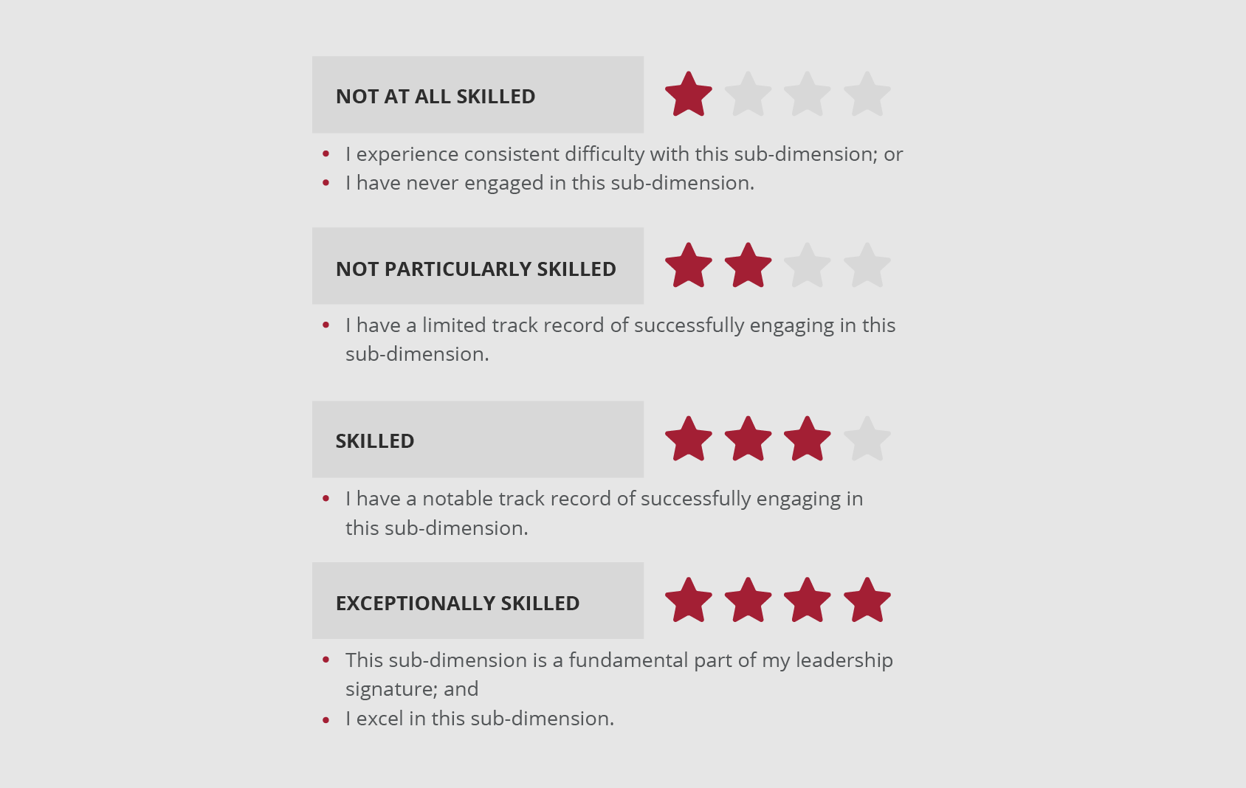

**Figure 1:** Guidelines for categorizing your skill level in a sub-dimension.

When making your selection, think carefully about how you, as a leader, have engaged in each sub-dimension. Be honest with yourself about your skills – identifying your strengths and weaknesses will help you to decide how to address your selected organizational challenge or opportunity.

Next, use the drop-down menu in the second column of the table to rate the relevance of each sub-dimension to your selected organizational challenge or opportunity. Figure 2 provides you with guidelines for rating the relevance of a sub-dimension.

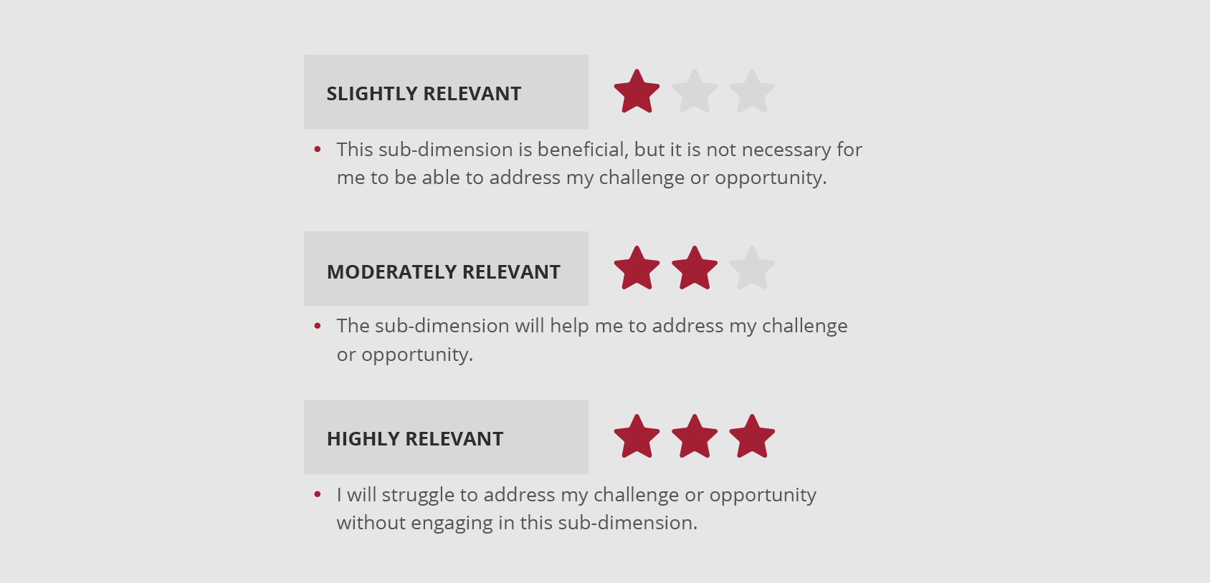

**Figure 2:** Guidelines for rating the relevance of a sub-dimension.

When making your selection, think carefully about the specific characteristics of each sub-dimension to help you rate its relevance to your selected organizational challenge or opportunity.

Populate Table 1.

**Table 1:** Categorize your skills and rate the relevance of each sub-dimension.

|  |  |  |
| --- | --- | --- |
| **Sub-dimension** | **Skill level** | **Relevance** |
| Visioning: Framing the vision | Skilled | Highly relevant |
| Visioning: Creating urgency for change | Not particularly skilled | Highly relevant |
| Visioning: Building a shared vision | Not particularly skilled | Highly relevant |
| Inventing: Executing | Exceptionally skilled | Moderately relevant |
| Inventing: Creating a learning culture | Exceptionally skilled | Moderately relevant |
| Inventing: Making tough decisions | Not particularly skilled | Slightly relevant |
| Inventing: Managing change | Skilled | Highly relevant |

##### Question 2

Consider how you can engage in visioning and inventing for your selected organizational challenge or opportunity.

While you may be able to take the lead in the sub-dimensions in which you are more skilled, you may need to reach out to others for the sub-dimensions in which you are less skilled. Keep your responses in Question 1 in mind as you answer Questions 2.1, 2.2, and 2.3.

###### Question 2.1

What vision would you like to achieve for your selected organizational challenge or opportunity, and how can you take the lead in terms of visioning? In your answer, consider the following:

* Reiterate what your selected organizational challenge or opportunity entails.
* Clearly describe your vision for your selected organizational challenge or opportunity.
* Consider where your strengths lie in terms of the sub-dimensions of visioning.
* Review which visioning sub-dimensions are relevant for your selected organizational challenge or opportunity.
* Explain how you can engage in visioning to inspire and motivate others to address your selected organizational challenge or opportunity. How will you frame your vision, create urgency for change, and build a shared vision?
* Be specific. What will you actually do next week, next month, and next year in order to engage in visioning?

(200–250 words)

Start writing here:

My organizational challenge is to influence the digital technology team at GE BioPharma to collaboratively research, define and share our 2020 digital marketing vision and roadmap[1].

I believe that our company should focus on:

* Fast, iterative cycles of identifying customer pain points, proposing solutions and testing those solutions with real customers.
* Providing a reliable and delightful customer experience by framing our initiatives as “User Experience[2]-first”

And that focusing on these 2 areas will yield significant improvements in value delivered to customers, thereby improving our customer lifetime value[3].

[continues on next page]

Figure 1

Figure 1, above, shows a scatter plot of Visioning sub-dimensions and their relevance to my organizational challenge. “Framing the vision” is an area where I am skilled and which has high relevance to my challenge. In order to successfully frame this vision, I will rely on my prior efforts in sensemaking to illustrate to my peers how executing our digital strategy will contribute to their goals, as well as to our competitive advantage and future innovation.

In April 2020, I will create and share a roadmap of our 2020 plans which shows the projects we’ll deliver. This roadmap will thematically categorise our projects according to the objectives and requirements they fulfill for the wider organization. Figure 2, opposite, shows an example of how I will categorise projects (left-hand column) with the organisation’s Strategic Objectives (far right-hand column). My hope is that this categorization will clearly frame and position the digital roadmap according to stakeholder and company goals.

Figure 2

I will also research and share an audit of our competitors’ digital presence – the technology and solutions they offer in similar communication channels. I’ll conduct an assessment of the value they offer to customers, and indicate how we compare in our offerings. By showing how competitors are solving similar problems, I will outline the “nightmare scenario[4]” of being outmatched and the loss of business which could result.

How can you engage in inventing to mobilize others to achieve the vision you outlined in Question 2.1, and thereby address your selected organizational challenge or opportunity? Be specific about how you can take the lead in terms of inventing. In your answer, consider the following:

* Clearly describe a structure or process you would invent to achieve the vision for your selected challenge or opportunity.
* Consider where your strengths lie in terms of the sub-dimensions of inventing.
* Review which inventing sub-dimensions are relevant for your selected organizational challenge or opportunity.
* Explain how you can engage in inventing to mobilize others and address your selected organizational challenge or opportunity. How will you make decisions and manage change? How will you continue to execute while also innovating?
* Be specific. What will you actually do next week, next month, and next year in order to engage in inventing?

(200–250 words)

Start writing here:

Figure 4

Figure 4, above, shows a scatter plot of Inventing sub-dimensions and their relevance to my organizational challenge. “Managing Change” is where I will focus my personal energy, because it is highly relevant to my challenge and an area where I am skilled.

Digital marketing is a relatively new and evolving discipline within marketing[5]. My experience working as a digital marketer informs me that many marketers may hesitate to embrace it as part of a wider marketing strategy because they find it inaccessible and difficult to understand. This can be a significant barrier to adoption of change. I intend to overcome this by:

* Collaboratively (with my direct reports) building a digital intranet site which will house training materials, “jargon-busting” digital definitions and a means for marketers to reach out to the digital team with questions.
* Explaining digital marketing with reference to more traditional marketing techniques, thereby providing a point of referral for my colleagues.

This intranet site will also help to support the sub-dimension of “creating a learning culture”. I will enhance this sub-dimension by encouraging and celebrating experimentation within our group. Taking inspiration from an example shared by Maeve Coburn of L’Oreal[6], I will look out for opportunities to publicly share my own experimentation and mistakes, drawing attention to what I learned.

To maintain a balanced approach to execution, I will consider how the digital team can operate in an “ambidextrous” manner (O’Reilly and Tushman, 2004). To deliver results, I will ask my team to create and share weekly trackers to see how we are performing against our goals, and ask them to suggest how we can correct course when necessary. To maintain innovation, I will work with the entire digital marketing team to create quarterly “innovation” sessions – inviting external and internal speakers to share ideas and approaches, to stimulate new thinking. I’ll ask our CMO to commit to implementing at least one idea per innovation session.

###### Question 2.3

Can you take the lead in every required aspect of visioning and inventing, or should you reach out to others to complement your leadership? In your answer, consider the following:

* Consider where your weaknesses lie in terms of the sub-dimensions of visioning and inventing.
* Review whether the sub-dimensions in which you are not as skilled are relevant for your selected organizational challenge or opportunity.
* Explain the sub-dimensions for which you should reach out to others to complement your leadership when addressing your selected organizational challenge or opportunity.
* If you feel that you can take the lead in every required aspect and do not need to reach out to others, explain why this is the case.

(100–150 words)

Start writing here:

There are 2 sub-dimensions where I am not particularly skilled but which are highly relevant to my challenge.

**Building a shared vision**

I believe I can suffer from having fixed ideas about how best to approach problems. This can be off-putting for my colleagues if I am seen to reject their suggestions and ideas in favour of my own. I will compensate for my lack of skill in this area by:

* Seeking internal coaching and support from someone who I perceive as being highly skilled at this sub-dimension. I will ask them to screen my ideas and communication, giving me suggestions on how to make projects more inclusive and collaborative. I’ll pay particular attention to advice received and model behavior from this coach when planning moments to share ideas with others.
* Identifying sources of excitement for my team and colleagues. I will treat these sources of excitement in a similar manner to strategic objectives (see figure 2, question 2.1) – I will categorise my projects according to the excitement they will create for others. If projects do not deliver excitement, I will reflect on how I could change this.

Although creating urgency for change is not a personal strength, my hope is that I can empower my team and colleagues to advocate, with urgency, for this change on my behalf. I believe that if I genuinely understand, frame and represent others’ objectives in my plan, specifically showing how our digital resources can help achieve their goals, that they will feel a sense of urgency to collaborate and deliver our roadmap in service of their objectives. If I can succeed, I believe that advocacy from others will communicate this urgency in more powerful terms than if I tried to signal this urgency alone.

##### Question 3

How will you build credibility as a leader while addressing your organizational challenge or opportunity? In your answer, consider the following:

* Explain how you will lead with integrity.
* Explain how you will lead with a shared purpose.

(100–150 words)

Start writing here:

I’ll aim to build credibility in 3 particular ways:

**Contact time with stakeholders**

I will prioritise and commit to regular, recurring time spent sharing ideas with my stakeholders. This time will be spent discussing the digital vision but also more widely discussing my stakeholders’ experiences and objectives. My goal will be to keep these people informed and maintain their sense of ownership and involvement in the digital plan. I will listen out for new information which may affect how we execute, and adjust our operations as necessary.

**Document and share follow-through**

As we begin to deliver projects within the digital roadmap, I will make sure each project has a clearly defined outcome and KPIs which have been defined in partnership with my stakeholders. I will measure how we perform and share this throughout the organization, making sure that successes and important lessons are explained.

**Exemplify and model experimentation, embracing mistakes and a learning culture.**

I will “lead from the front” in taking an experimental approach. The scope of this experimentation will be towards the technology we implement and the processes we use in support of the technology. I’ll make explicit that there are uncertainties in our expected results, but that we must be decisive and willing to learn. Whenever possible, I will share my own mistakes and learnings, which I hope will encourage others to be forthcoming in their own learning.

#### 3. Rubric

Your submissions will be reviewed according to the following rubric.

|  |  |  |  |  |
| --- | --- | --- | --- | --- |
|  | **Criteria not met** | **Criteria met** | **Good** | **Exceptional** |
| **Rate visioning and inventing skills, as well as the relevance of the visioning and inventing sub-dimensions for the selected organizational challenge or opportunity (Question 1).**  *Participant rates their skills in relation to each visioning and inventing sub-dimension, as well as the relevance of each visioning and inventing sub-dimension for the selected organizational challenge or opportunity, using the provided table.* | No submission or attempt. | The provided table is populated to a certain degree, but about half of the rows are empty. | The provided table is populated to a certain degree, but some rows are empty. | The provided table is fully populated. |
| **Describe a vision and explain how to take the lead in terms of visioning for the selected organizational challenge or opportunity (Question 2.1).**  *Participant describes  their vision for the selected organizational challenge or opportunity. Participant explains how they can engage in visioning for their selected organizational challenge or opportunity, based  on their answers in  Question 1. This includes identifying their strengths, reviewing the relevance of the sub-dimensions, and identifying the specific behaviors they can enact.* | No submission or attempt.  OR  The response is not related to the question. | Participant partially describes the vision for the selected organizational challenge or opportunity, and how they can take the lead in terms of visioning. However, at least one aspect of the answer is irrelevant or inadequately addressed. | Participant adequately describes the vision for the selected organizational challenge or opportunity, and how they can take the lead in terms of visioning. All relevant aspects are addressed. | Participant perceptively describes the vision for the selected organizational challenge or opportunity, and how they can take the lead in terms of visioning. All relevant aspects are insightfully addressed. |
| **Describe a structure or process and explain how to take the lead in terms of inventing for the selected organizational challenge or opportunity (Question 2.2).**  *Participant describes a structure or process they would invent to achieve the vision for their selected challenge or opportunity. Participant explains how they will engage in inventing for their selected organizational challenge or opportunity, based  on their answers in  Question 1. This includes identifying their strengths, reviewing the relevance of the sub-dimensions, and identifying the specific behaviors they can enact.* | No submission or attempt.  OR  The response is not related to the question. | Participant partially describes a structure or process they would invent to achieve the vision for their selected challenge or opportunity, and how they can take the lead in terms of inventing. However, at least one aspect of the answer is irrelevant or inadequately addressed. | Participant adequately describes a structure or process they would invent to achieve the vision for their selected challenge or opportunity, and how they can take the lead in terms of inventing. All relevant aspects are addressed. | Participant perceptively describes a structure or process they would invent to achieve the vision for their selected challenge or opportunity, and how they can take the lead in terms of inventing. All relevant aspects are insightfully addressed. |
| **Explain whether leadership should be complemented by others (Question 2.3)**  *Participant explains the sub-dimensions for which they should reach out to others to complement their leadership, based  on their answers in  Question 1. This includes considering their weaknesses and reviewing the relevance  of the sub-dimensions. Alternatively, participant explains why they are able to take the lead in every aspect, based on their answers in Question 1.* | No submission or attempt.  OR  The response is not related to the question. | Participant partially explains the sub-dimensions for which they should reach out to others to complement their leadership, or why they can lead in all aspects required. However, at least one aspect of the answer is irrelevant or inadequately addressed. | Participant adequately explains the sub-dimensions for which they should reach out to others to complement their leadership, or why they can lead in all aspects required. All relevant aspects are addressed. | Participant perceptively explains the sub-dimensions for which they should reach out to others to complement their leadership, or why they can lead in all aspects required. All relevant aspects are insightfully addressed. |
| **Explain how to build credibility as a leader (Question 3).**  *Participant explains how they will lead with integrity and a shared purpose while addressing their selected organizational challenge or opportunity.* | No submission or attempt.  OR  The response is not related to the question. | Participant partially explains how they will lead with integrity and a shared purpose while addressing their selected organizational challenge or opportunity. However, at least one aspect of the answer is irrelevant or inadequately addressed. | Participant adequately explains how they will lead with integrity and a shared purpose while addressing their selected organizational challenge or opportunity. All relevant aspects are addressed. | Participant perceptively explains how they will lead with integrity and a shared purpose while addressing their selected organizational challenge or opportunity. All relevant aspects are insightfully addressed. |
| **Structure and logic of writing**  *Submission is clearly and logically structured.* | No submission or attempt. | Submission has some logical structure and is clear enough to comprehend. | Submission is well-structured in terms of logic and clarity. | Submission is exceptionally well-structured in terms of logic and clarity. |

1. Donal Phipps MIT SL M1U3 Ongoing project, submitted 9th March 2020
2. <https://www.nngroup.com/articles/definition-user-experience/>
3. <https://en.wikipedia.org/wiki/Customer_lifetime_value>
4. Professor Ancona, MIT Sloan Leadership in an Exponentially Changing World, Module 4
5. <https://en.wikipedia.org/wiki/Digital_marketing>
6. MIT Sloan Leadership in an Exponentially Changing World, 5.4 “How leaders approach inventing and building credibility”